# Chapter 1: Introduction for Critical Thinking.

**Critical thinking** meansskilled judgment or observation by clear intellectual standards

(Tư duy phản biện có nghĩa là đánh giá hoặc phán đoán một cách có kỹ năng dựa trên những tiêu chuẩn tri thức rõ ràng).

Critical thinking is the general term given to a wide range of cognitive(1) skills and intellectual(1) dispositions needed:

-To effectively identify, analyze, and evaluate arguments and truth claims,  
-To discover and overcome personal prejudices(2) and biases(3),  
- To formulate and present convincing reasons in support of conclusions; and  
-To make reasonable, intelligent decisions about what to believe and what to do.

(*Cognitive, intellectual*: thuộc về nhận thức, trí óc. ***Prejudice***: định kiến, ***Bias***: thành kiến)

**Eight standards of critical thinking:**

**(08 tiêu chuẩn của tư duy phản biện)**

**1. Clarity (sự rõ ràng):** Clarity is a **gateway standard**. Clarity in expression is a sign of intelligence. Critical thinkers strive for clarity of language and thought. (bạn có thể nói rõ hơn không, bạn có thể cho một ví dụ, bạn có thể minh họa cho điều mà bạn muốn nói)



**2. Accuracy (tính đúng đắn): (- Accuracy: True, not False)** A statement can be **clear**, but **not accurate** as in the example: “Most chickens weight over 300 pounds in weight.” (làm sao chúng ta có thể kiểm tra/ chứng thực chuyện đó, Làm sao chúng ta biết được điều đó là đúng).



Ex: Teacher: “Some students are absent from class today. They are not here because they had registered but then dropped.”

→ Question to check accuracy: Is that really true?

3**. Precision (sự chính xác và cụ thể): (- Precise: Specific, not General)** A statement can be **both clear and accurate, but not precise**. Ex: “He’s a countryside man. Inviting him to a party at a five-star hotel is like pulling a fish out of water” (cần cụ thể hơn, không dẫn tới những suy nghĩ ẩn dụ, có thể đưa ra nhiều chi tiết hơn không, có thể chính xác nó hơn không?).



- Critical Thinking is a useful subject.

- Really? Why is it useful?

- Yeah, it’s really helpful.

- ???

→ **Question to check precision**: Can it/you be more **specific**?

After transferring 35 people, there are 58 people in the group of welders on the bridge. How many welders were there initially?

→No, the math problem is not PRECISE: who are those 35 people? Can they be builders or vendors?

**4. Relevance (sự liên quan) :** Điều đó có liên quan như thế nào tới vấn đề, Điều đưa ra giúp gì cho ta trong vấn đề này. Vd: *He is handsome. Therefore, he will pass the Calculus 1 test. ( việc đẹp trai không liên quan tới vấn đề pass Cal 1 hay không.*



**5. Consistency (tính nhất quán)** A person holds inconsistent beliefs, at least one of those beliefs must be false.  
+ 2 kinds of inconsistency **(không nhất quán)**:



- Logical inconsistency: involves saying or believing inconsistent things (i.e. things that cannot both or all be true) about a particular matter.

A: Which do you favor: happy moments with your family or happiness counting money?

B: I love being with my family, of course.

A: What can you do for your family?

B: I work day & night to earn money for them.

Khi hai ta về một nhà   
Khép đôi mi chung một giường   
Đôi khi mơ cùng một giấc   
Thức giấc chung một giờ   
Khi hai ta chung một đường   
Ta vui chung một nỗi vui   
Nước mắt rơi một dòng   
Sống chung nhau một đời

- Practical inconsistency: saying one thing and doing another.

**6. Logical correctness (lập luận/tính logic):** When we think, we bring a variety of thoughts together in some order. When the combination of thoughts is mutually supporting and makes sense in combination, the thinking is “**logical**.” (tất cả chuyện này có ý nghĩa gì không? Đoạn đầu tiên có hợp với đoạn cuối không? Những gì bạn nói có xuất phát từ bằng chứng hay không? Có sự ngụy biện nào trong câu nói của bạn hay không?)



Nun: I have to wear a bathrobe when having a bath. Because God sees everything, he will see through the door.

**7. Completeness *(*sâu sắc, có chiều sâu*)*** We rightly prefer deep and complete thinking to shallow (nông cạn) and superficial (hời hợt) thinking. (Những nhân tố nào khiến vấn đề này trở thành một vấn đề khó, những khó khăn nào ta cần xử lí trong vấn đề này).



**8. Fairness:**



🡪Fair-mindedness is an essential attribute of a Critical Thinker. (Chúng ta có bất kì tư lợi nào trong này hay không? Chúng ta có trình bày trung thực những quan điểm của người khác không?)

🡪The ability to recognize all sides of an issue: broad view or thinking  
(Chúng ta có cần xem xét vấn đề dựa trên những khía cạnh khác, những viễn tưởng nào khác nữa không, có góc nhìn đối lập nào chưa được xem xét không)

**A:** A singer with tattoos? Unacceptable!

***Benefits of Critical Thinking***′**Academic Performance (In the classroom)**λ Understand the arguments and beliefs of others  
λ Critically evaluating those arguments and beliefs  
λ Develop and defend one's own well-supported arguments and beliefs.

* Understanding and critically evaluating the arguments and beliefs of others
* Developing and defending one’s own well-supported arguments and beliefs

′ **Workplace (In the workplace)**λ Helps us to reflect and get a deeper understanding of our own and others’ decisions  
λ Encourage open-mindedness to change  
λ Aid us in being more analytical in solving problems

* Communicate clearly and effectively
* Gather and analyze information
* Draw appropriate conclusions from data
* Solve problems
* Think creatively

**Daily life (In life)**λ Helps us to avoid making foolish(dại dột) personal decisions.  
λ Promotes an informed and concerned citizenry capable of making good decisions on important social, political and economic issues.  
λ Aids in (hỗ trợ trong) the development of autonomous(tự chủ) thinkers capable of examining their assumptions, dogmas(giáo điều), and prejudices.

* Preventing people from making foolish personal decisions
* Promoting good decisions for the benefit of the people

***Barriers to critical thinking (Các rào cản của tư duy phản biện)***• lack of relevant background information  
• poor reading skills  
• bias  
• prejudice  
• superstition  
• **egocentrism (self-centered thinking)**  
• **sociocentrism (group-centered thinking)**  
• peer pressure  
• conformism  
• provincialism  
• narrow-mindedness  
• closed-mindedness  
• distrust in reason  
**• relativistic thinking *(thuyết tư duy tương đối trong mọi vấn đề)***  
• stereotyping  
**• unwarranted assumptions**  
• scapegoating  
• rationalization



• denial  
**• wishful thinking**  
• short-term thinking  
• selective perception  
• selective memory  
• overpowering emotions  
• self-deception  
• face-saving



• fear of change

1. Egocentrism (**Self-interested thinking**)
2. Sociocentrism (**Group bias, Tribalism, Conformism**)
3. Unwarranted assumption & Stereotype (**Claiming that something is true without true evidence**)
4. Relativistic thinking (**Subjectivism, Cultural relativism**)
5. Wishful thinking (**Believing something not because you have good evidence for it but because you wish it were true**)

Tự cho mình là đúng, coi giá trị,  
tư tưởng của bản thân mình là  
cao hơn tất cả những người khác

***Self-serving bias(thiên kiến tự đề cao)***: "If it's a success, it's because of me. If it's a failure, it's because of someone or something else." For example, if I met my sales target, it's because I'm a great salesperson. But if I did not meet my sales target, it's because the  
economy is bad.



**Tư lợi (ích kỷ)** Vd: Nghĩ về lợi ích của, nhu cầu của bản thân trên những lợi ích, nhu cầu chung của tất cả  
mọi người



(Giả định không có cơ sở và rập khuôn)

(Thuyết Nhóm làm trung tâm/Tư duy Nhóm làm trung tâm)

Tribalism (chủ nghĩa bộ lạc)

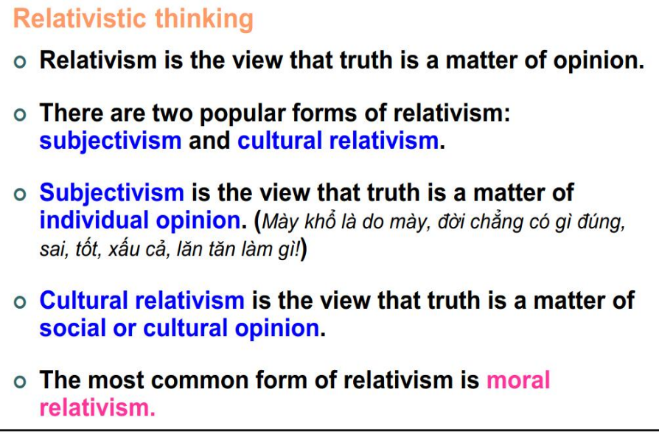



# **Chapter 2:**

**A fact** is a thing that is occurred, to exist, or to be true.( **A fact is a statement that can be verified. It can be proven to be true or false through objective evidence.**)



**An opinion is** a statement that expresses a feeling, an attitude, a value judgment, or a belief. It is a statement that is neither true nor false (Ý kiến ​​là một tuyên bố thể hiện một cảm giác, một thái độ, một đánh giá giá trị hoặc một niềm tin. Đó là một tuyên bố có thể đúng hoặc sai.) (**An opinion is a statement that expresses a feeling, an attitude, a value judgment, or a belief. It is a statement that is neither true nor false**)



A statement is a sentence that makes good grammatical sense when it is prefaced with the words  
**"It is true that…" or "It is false that…”.**



A statement is a sentence that can be viewed as either true or false. (Tuyên bố (Trình bày): câu / câu nói có thể được xem là đúng hoặc sai).



Four things should be noted about statements.  
1. First, a sentence may be used to express more than one statement.  
2. Second, a statement can sometimes be expressed as *a phrase* or *an incomplete clause*, rather than as a complete declarative sentence.  
3. Third, not all sentences are statements, that is, sentences *that either assert or deny that something is the case.*4. Finally, *statements can be about subjective matters of personal experience* as well as *objectively verifiable matters of fact*.



**Non-Statements: (Không phải là tuyên bố nếu):**



* Questions (Câu hỏi)



Ex: On what day do we study Critical Thinking? Question

* Greetings (Lời chào)



Ex: Hi, my dear IUers

* Commands (Mệnh lệnh)



Ex: Don’t come to class late next time!

* Requests (Yêu cầu)



Ex: Please do some reading before each class meeting

* Proposals (Đề xuất)



Ex: Let’s submit our assignments before the deadline.

* Instructions (Hướng dẫn)



Ex: Office of Academic Affairs: “Be advised to keep Blackboard open for instant notices*”*

* Exclamations (Cảm than)



Ex: Oh dear!

**Tricky Statement - Rhetorical question (câu hỏi tu từ)**

Sentence that has the grammatical form of a question but is meant to be understood as a statement/assertion (tuyên bố/khẳng định).

Not ask for information, but to make a positive assertion that the speaker or writer expects at least some of his readers or listeners to agree with.

Examples:

Don’t you know smoking will kill you? (Meaning: Smoking will kill you)

How am I supposed to do that? (Meaning: I can’t do that).

**Tricky Statement - Ought imperative (câu mệnh lệnh)**

**Ought imperative** should be regarded (được coi) as statements.

Sentence that has the form of a command/imperative but is intended to assert what ought to be done.

Examples:

“Do X!” really means “You should do X”

“Don’t blow-dry your hair in the tub!” really means “You should not blow-dry your hair in the tub”

**Argument (lập luận/luận cứ)** - A form of thinking in which certain statements reasons are offered in support of another statement – a conclusion.

**Argument** is the core of **critical thinking**. **Only statements are used in arguments.**

**Arguments** are composed of one or **more *premise(s)* and a *conclusion(s)***.

🡪 Premises are statements offered as reasons for accepting another statement, involve **evidence** including reasons, examples, facts, figures, etc. (**premises là TIỀN ĐỀ**)

🡪A conclusion is a statement supported by reasons

**WHAT IS AN ARGUMENT?**

This is an argument in which the speaker uses a fact to support his/her opinion.

This is an argument in which the speaker uses an opinion to support his/her opinion.

This is not an argument because there is no opinion; only two facts are given.

**Identifying Premises and Conclusions**

**Indicator words** provide clues that premises or conclusions are being put forward

* **Premise indicators**: Since, for, seeing that, inasmuch as, in view of the fact that, because, as, and given that, considering that, as indicated by, on account of, etc.



* **Conclusion indicators**: Therefore, hence, so, it follows that, wherefore, thus, consequently, accordingly, for this reason, which shows that, this suggests that, this being so, etc.



Indicators:

* May be misleading.
* May be absent in some cases.

**Finding Conclusions When Indicators Are Absent:**

1. Find the main issue and determine the position of the writer or speaker on that issue.
2. Look at the beginning or the end of the passage; the conclusion is usually found in one of those places.
3. A statement is probably the conclusion if the word “therefore” fits well before it.
4. The “because” trick (fill in the blanks): The arguer believes (conclusion) because (premise(s)).

**What Is Not an Argument?**

🡪Arguments consist of statements: non-statements cannot be parts of arguments.

🡪An argument always consists of at least two statements.

**Non-arguments (không phải là tranh luận, lập luận nếu là)**

1. **Reports (báo cáo)**: Convey information about a subject.



1. **Unsupported assumptions (các khẳng định không có cơ sở)**: When someone puts forth what he/she believes but does not intend for any of his/her statements to support another. (**unsupported assertion**)



1. **Conditional (“if-then”) statements(câu điều kiện).**



1. **Chain arguments (lập luận chuỗi):** Arguments can be composed entirely of conditional statements. Ex: “If Bob is taller than Chris, then Bob is taller than Ann. If Bob is taller than Ann, then Bob is taller than Lori.”
2. **Illustrations(minh họa):** Do not prove or support the claim but provide examples of the claim. Example: “Many wildflowers are edible(ăn được). For example, daisies and day lilies are delicious in salads.”



1. **Explanation(giải thích):**Tries to show why something is the case, not to prove that it is the case. Ex: “Titanic sank because it struck an iceberg”



**Assumption**: hidden belief/principle that that decides the value of the conclusion. (Giả định: niềm tin / nguyên tắc ẩn quyết định giá trị của kết luận)



Examples:

2. There is nothing wrong searching answers on the mobile phone during an online test. Other students do it quite often.

Giả định**:** Việc sinh khác dùng điện thoại tìm kiếm đáp án là không sai



3.You should be careful with your possessions when you’re on buses. I lost my laptop last month.

Giả định**:** Việc mất cắp trên xe bus xảy ra (đến từ kinh nghiệm bản thân)



4.We should ask any questions in class if we don’t understand or are still confused. We can learn from our teacher and our friends as well.

Giả định**:** Chuẩn bị bài hay không thì không hiểu chỗ nào thì cứ hỏi thoải mái



# **Chapter 3+11: Basic Logical Concepts**

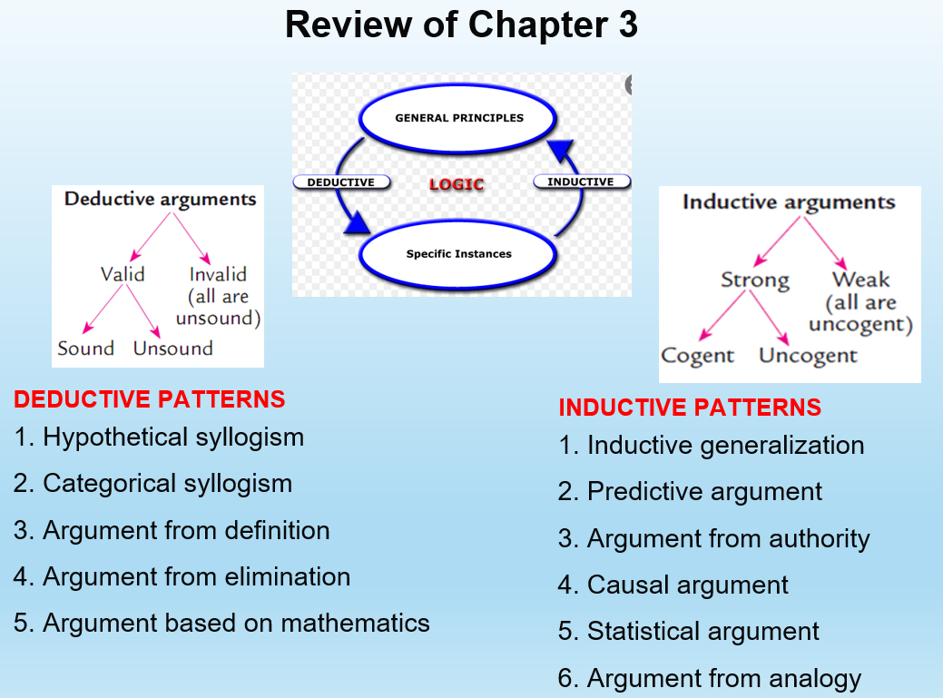

**Two basic categories of human reasoning:**

* **Deduction:** reasoning from general premises, which are known or presumed to be known, to more specific, certain conclusions (formal reasoning)



**(Diễn giải:** suy luận dựa trên **tiền đề chung**, đã biết hoặc được cho là đã biết để đưa ra những kết luận chắc chắn, cụ thể hơn (suy luận chính thức))



Examples:

🡪According to the World Health Organization, the objective of a booster dose is to restore vaccine effectiveness from that deemed no longer sufficient. I took the second vaccine shot 6 months ago. Therefore, I have to rush for a booster dose.

* **Induction:** reasoning from specific cases to more general, but uncertain, conclusions (informal reasoning)



**(Quy nạp:** suy luận rút ra từ các **trường hợp cụ thể** để đưa ra kết luận tổng quát hơn, nhưng không chắc chắn (suy luận không chính thức))



Examples:

🡪Today, some late students in our class said they had to take the booster vaccine shot. Probably all students were late today because of booster vaccination.

🡪 So far, every class, the professor has worn a tie. Therefore, next class, the professor will wear a tie.

**Deduction and Induction: Avoid a Misconception**

+ Common **deduction** indicator words include words or phrases like *necessarily*, *logically*, *conclusively, certainly, definitely it must be the case that, and this proves that., this entails that…*+ Common **induction** indicator words include words or phrases like *probably*, *likely*, *it is plausible to suppose that*, *it is reasonable to think that*, and *it's a good bet that*, *probably, likely, one would expect, reasonable to assume,…*

**\***The ***strict necessity test*** asks whether the conclusion follows from the premises with strict logical necessity. If it does, then the argument is **deductive.  
\***The ***common pattern test*** asks whether the argument exhibits a pattern of reasoning that is characteristically deductive or inductive. If the argument exhibits a pattern of reasoning that is characteristically deductive, then the argument is probably deductive.

**COMMON PATTERNS OF DEDUCTIVE REASONING**

**(Một số kiểu phổ biến của suy luận diễn giải)**

1. **A Hypothetical Syllogism (Thuyết tam đoạn luận dựa trên những giả thuyết) is simply a three – line argument, exactly two premises and a conclusion.**



**Valid Versions:**

1. **Chain argument – Lập luận dạng chuỗi**

Pattern: If A, then B.

If B, then C.

Therefore, if A then C.

Example: If you miss the bus, you’ll be late for class.

If you’re late for class, you’ll miss the lesson.

So, if you miss the bus, you’ll miss the lesson.

1. **Modus ponens – affirming the antecedent - dạng khẳng định tiền tố**

Pattern: If A, then B.

**A.**

Therefore, B

Example: If you want to get a scholarship, you’ll have to study hard.

You certainly want to get the scholarship.

Therefore, you’ll have to study hard.

1. **Modus tollens – denying the consequent - từ chối hậu quả/vế sau**

Pattern: If A, then B.

**Not B.**

Therefore, not A.

Example: If you live in Paris, then you live in France.

You don’t live in France.

Therefore, you don’t live in Paris.

**Invalid Versions:**

1. **Denying the antecedent - từ chối vế trước**

Pattern: If A, then B.

**Not A.**

Therefore, not B.

Example: If Mr. Smith is President of the U.S., then he’s a famous person.

Mr. Smith is not President of the U.S.

Therefore, he’s not a famous person.

1. **Affirming the consequent - khẳng định vế sau**

Pattern: If A, then B.

**B**.

Therefore, A.

Example: If you live in Paris, then you live in France.

You live in France.

Therefore, you live in Paris.

1. **A categorical syllogism (Thuyết tam đoạn luận dựa trên phân loại) may be defined as a three- line argument in which each statement begins with the word all, some, or no.**



**Example 1**: With **‘All’**

**All** Critical Thinking books contain deductive and inductive arguments.

**All** deductive and inductive arguments are patterns of logical reasoning.

So**, all** Critical Thinking books contain patterns of logical reasoning.

***Typical Forms:***♦ All a’s are b’s. All b’s are c’s. Therefore, all a’s are c’s.  
♦ Some a’s are b’s. All b’s are c’s. Therefore, some a’s are c’s

1. **Argument by Elimination (Lập luận bằng sử dụng loại bỏ)**: seeks to logically rule out various possibilities  
   until only a single possibility remains.  
   ♦ ***Typical forms***: A or B. Not B. Therefore A.



**Example 1:**  Either you are married or you are single by law.

You are not married.

Then you are single by law.

1. **Mathematics** is a model of logical, step-by step reasoning. In an argument based on mathematics, the conclusion is claimed to depend largely or entirely on some mathematical calculation or measurement.  
   ***Example***:  
   *Light travels at a rate of 186,000 miles per second. The sun is more than 93 million miles distant from the earth. Therefore, it takes more than eight minutes for the sun’s light to reach the earth.*



1. In **Argument from definition**, the conclusion is presented as being “true by definition”, that is, as following simply by definition some key word or phrase used in the argument.  
   ***Example:****Janelle is a cardiologist. Therefore, Janelle is a doctor.  
   Bertha is an aunt. It follows that she is a woman.*



***

Mary is 13 years old. Therefore, she is a teenager.

*(Mary 13 tuổi. Do đó, cô ấy là một thiếu niên.)*

Definition of a teenager: a person aged between 13 and 19 years.

**Deductive validity (Tính hợp lệ của suy luận diễn giải)**

* **Valid deductive arguments:** conclusion must follow from premises; in other words, it’s impossible that all premises are true but the conclusion is false *(kết luận phải theo từ tiền đề; nói cách khác, không thể có tất cả các tiền đề là đúng nhưng kết luận là sai)*

**Example 1**:

If you want to get a scholarship, you’ll have to study hard.

You certainly want to get the scholarship.

Therefore, you’ll have to study hard.

* + **Valid (Hợp lệ)**

**Example 2**:

If you want to get a scholarship, you’ll have to study hard.

You don’t study hard at all.

Therefore, you will get the scholarship.

* + **Invalid (Không hợp lệ)**
* **Valid deductive arguments:** may be sound or unsound

**Example 1**:

All International University students do their majors in English.

I’m an International University student.

Therefore, I do my major in English.

* + **Valid and sound (true) – Hợp lệ và đúng**

**Example 2**:

All International University students are aliens.

I’m an International University student.

Therefore, I’m an alien.

* + **Valid but unsound (true) – Hợp lệ nhưng không đúng**

**COMMON PATTERNS OF INDUCTIVE REASONING (Một số kiểu của suy luận qui nạp)**

1. **An inductive generalization (Tổng quát quy nạp)** is an argument in which a generalization is claimed to be probably true based on information about some members of a particular class. (Gặp người da đen ăn cắp => nghĩ đến việc tất cả người da đen ăn cắp)

Example:

My boyfriend never gives me a flower on Valentine or March 8. All men are so unromantic! (Bạn trai của tôi không bao giờ tặng tôi một bông hoa vào ngày Valentine hoặc ngày 8 tháng 3. Tất cả những người đàn ông đều vô cùng lãng xẹt!) 🡪Too hasty conclusion!

1. **Predictive argument *(Lập luận từ dự đoán)***: a prediction is defended with reasons.

Example:

* *It has rained in Vancouver every February since weather records have been kept. Therefore, it will probably rain in Vancouver next February.*
* Every time I come home with the smell of beer, my wife gets angry! I’ve just drunk a lot of beer. So my wife will get angry. (Mỗi lần về nhà nồng nặc mùi bia là vợ tôi lại cáu! Tôi vừa uống rất nhiều bia. Vì vậy, vợ tôi sẽ tức giận.)

1. **Argument from authority *(Lập luận đưa ra từ người/đơn vị giám sát)***: asserts a claim and supports that claim by citing some presumed authority or witness. ***(nếu như nguồn thông tin lấy được không đáng tin cậy 100% => inductive)***Common form: P said that A was true, therefore A is true.

Example:

* *More Americans die of skin cancer each year than die in car accidents. How do I know? My doctor told me.*
* HCMC International University has just confirmed that students will resume learning on campus in March 1. So I have to book a flight to HCMC now to attend the face-to-face lessons at the given time.

1. **Causal Argument *(Lý lẽ nhân quả)*:** asserts or denies that something is the cause of something else.  
   Common form: X is true. The likely cause of X being true is Y being true. Therefore, Y must be true.

Ex:

*I can’t log-in. The network must be down.*  
*Rashid isn’t allergic to peanuts. I saw him eat a bag of peanuts on the flight from Dallas.***Not all** causal arguments are inductive, if there are true evidences, they are deductive:  
*Ex: Whenever iron is exposed to oxygen, it eventually rusts.*

1. **A Statistical argument (Lập luận dựa trên thống kê)** rests on statistical evidence, that is, evidence that some percentage of some group or class has some particular characteristic:

Example

* ⁄*Eighty-three percent of Trinity’s students are Anglican. Beatrice is a Trinity’s student. So, Beatrice is probably Anglican.* (Statistical evidence can be used in **deductive** reasoning)
* 100% of IU students have to learn Critical Thinking while this subject is optional at University X. Therefore, IU has more critical thinkers than University X.

(100% sinh viên IU phải học Tư duy phản biện trong khi môn học này là môn học không bắt buộc tại Đại học X. Vì vậy, IU có nhiều nhà tư duy phản biện hơn Đại học X.)

1. **An analogy is a comparison of two o**r more things that are claimed to be alike in some relevant respect. In an **Argument from analogy**, the conclusion is claimed to depend on an analogy between two or more things  
   Common form:  
   *These things are similar is such-and-such ways. Therefore, they are similar in some further way*Examples:

* *Hershey Park is a great amusement park and it has a great roller coaster. Dorney  
  Park is a great amusement park. Dorney Park probably has a great roller coaster.*
* A is an IU student and she’s confident and dynamic.

B is an IU student and he’s confident and dynamic.

C is an IU student, so I’m sure she’s confident and dynamic.

**Inductive strengths**

* **Strong inductive argument**: an inductive argument the premises of which, if true,make the conclusion likely or probable*(Kết luận có lẽ đúng nếu tiền đề là đúng.)*  
+ If the premises are true, the conclusion is probably true.

**Common form:**+ Most b’s are p.  
+ X is a b.  
+ Therefore, (probably) X is p

Example 1:

Kim told me her family is not affordable for her college tuition. She has been studying so hard in the last year of high school. Kim is **probably** trying to gain a college scholarship. (**Strong)**

!!!Strong inductive arguments may be ***cogent*** or ***uncogent*** (Các lập luận quy nạp có thể có thuyết phục hoặc không thuyết phục)

Example 1:

It’s the rainy season and it has been raining for the last 3 days.

Therefore, it is probably going to rain today.

**Strong and cogent (convincing)**

Example 2:

Rainy days generally result in dry weather and it is raining now.

Therefore, we’ll probably have dry weather today.

**Strong but uncogent (at least one premise is false)**

\*\***Weak inductive argument**: inductive argument, the premises of which, do not provide good evidence for its conclusion. *(Các tiền đề, ngay cả khi chúng được giả định là đúng, không làm cho kết luận có thể xảy ra)*

Example 2:

About 5% of IU students are international students now. Kim is an IU student. So she is **probably** an international student. (**Weak)**

# **Chapter 9: A Little Categorical Logic (Logic theo nhóm)**

1. **Categorical propositions/claim (Phân loại các Mệnh đề)**

Categorical propositions/claims make declarations about entities belonging to, or not belonging to, categories or classes. Each standard categorical proposition has 4 basic parts:

1. **Quantifier:** *All*, *No*, or *Some* ***–*** Định lượng (Tất cả, Không, hoặc Một số)
2. **Subject**: (**S**) (plural noun) – Đối tượng
3. **Predicate (attribute)**: (**P**) (plural noun) – Thuộc tính (danh từ số nhiều)
4. **Copula**: linking verb (always ‘are’) – Động từ nối

Ex: All(1) IU students(2) **are(4)****Critical Thinking learners(3).**

**4 Common form**:

**P**

**S**

* All **S** are **P**
* No **S** are **P**
* Some **S** are **P**
* Some **S** are not **P**

**Venn diagram for a categorial proposition (Sơ đồ Venn cho phân loại mệnh đề)**

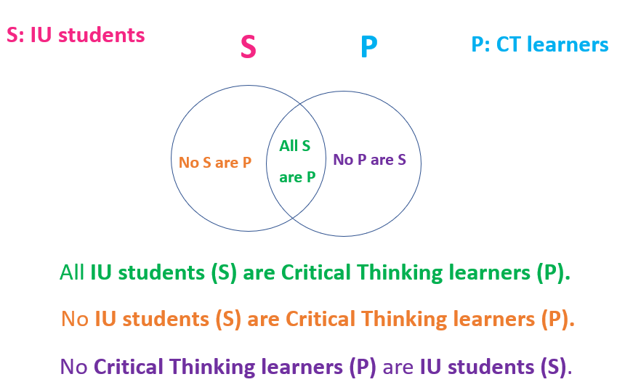

**Two simple rules governing Venn diagram (Hai quy tắc đơn giản sử dụng biểu đồ Venn)**

1. Shade an area to show that it is empty.

*(Che bóng (tô) một khu vực để cho thấy rằng tập rỗng (trống))*

2. Place an X in an area to show that it is occupied by some item (at least one item).

*(Đánh dấu X vào một khu vực để cho biết khu vực đó đang bị chiếm bởi một số mục (ít nhất một).)*

In summary, the four kinds of **standard-form categorical** **statements** are diagrammed as follows:

**All S are P**

**No S are P**

**Some S are not P**

**Some S are P**

**Common stylistic variants of categorical claims**

**(Các biến thể văn phong phổ biến của tuyên bố phân loại)**

**All “S” are “P” - Tất cả S là P**

***Tip to remember: All the propositions with words of extremes (any, always, only, whatever, whoever…) in the positive forms are converted into ‘All S are P’.***

***Attention: ‘If something is not a P, then it is not an S.’: double negative also means positive.***

|  |  |
| --- | --- |
| Every S is a P. | Example: Every dog is an animal |
| Whoever is an S is a P | Example: Whoever is a bachelor is a male. |
| Whatever is an S is a P | Example: Whatever is a lemon is a fruit. |
| If **anything** is an *S*, then it is a *P*. | ***Example****:* If anything is a lizard, then it is a reptile |
| If **something** is not a *P*, then it is not an *S*. | ***Example****:* If something is not a bird, then it is not a sparrow |
| Any S is a P. | Example: Any triangle is a geometrical figure. |
| Each S is a P. | Example: Each monkey is a primate. |
| S are **all** P | Example: Senators are all politicians |
| S are **always** P | Example: Racists are always bigots. |
| Only P are S. | Example: Only Catholics are popes. |
| **Only** if something is a *P* is it an *S*. | ***Example****:* Only if something is a fish is it a salmon. |
| The **only** *S* are *P* | ***Example****:* The only seats available are seats in the upper deck. |
| Something is an *S* **only if** it is a *P*. | ***Example****:* Something is an elm only if it is a tree. |

|  |  |
| --- | --- |
| **No** P are S.  **No S are P - Không S nào là P**  ***Tip to remember: These variants contain words of extremes in negative forms.*** | Example: No vegetables are fruits. |
| S are **not** P. | Example: Oaks are not conifers. |
| **Nothing** that is an S is a P | Example: Nothing that is a known fact isa mere opinion. |
| **No** one who is an S is a P  (Không ai là S là P) | ***Example****:* No one who is a Democrat is a Republican. |
| None of the S is a P  (Không S nào là P) | ***Example****:* None of the students is a registered Independent. |
| **Not** a single S is P | Example: Not a single U.S. president is a woman. |
| If anything is an S then it is **not** a P (Nếu bất cứ thứ gì là S thì nó không phải là P.) | Example: If anything is a plant, then it is not a mineral. |
| All S are **non**-P. | Example: All robots are nonhumans. |

**Some S are P – Một số S là P**

***Tip to remember: These variants contain quantifiers ranging from ‘’more than one’ to ‘nearly all’, and they are in the positive forms.***

|  |  |
| --- | --- |
| **Some** P are S. | Example: Some Democrats are women. |
| **A few** S are P. | Example: A few mathematicians are poets. |
| **There are S** that are P | Example: There are monkeys that are carnivores. |
| **Several** S are P | ***Example****:* Several planets in the solar system are gas giants. |
| **Many** S are P | ***Example****:* Many billionaires are Internet tycoons. |
| **Most** a single S is P | Example: Most high school principals are men |
| **Nearly all** S are P | Example: Nearly all Hollywood producers are liberals. |

**Some S are not P – Một số S không phải là P**

***Tip to remember: These variants contain quantifiers ranging from ‘’more than one’ to ‘nearly all’, and they are in the negative forms.***

|  |  |
| --- | --- |
| **Not all** P are S. | Example: Not all mammals are quadrupeds. |
| **Not** everyone who is an S is a P. | Example: Not everyone who is a used-car dealer is a crook. |
| **S** are **not** always P | Example: Sailors are not always swimmers. |
| **Some** S are non-P | ***Example****:* Some theologians are nonbelievers. |
| There are S that are **not** P | ***Example****:*  There are bears that are not carnivores. |
| **A few** S are **not** P | Example: A few logicians are not eccentrics. |
| SeveralS are **not** P | Example: Several of the world’s most famous sports celebrities are not good role models. |
| MostS are **not** P | Example: Most students are not binge drinkers. |
| Nearly all S are **not** P | Example: Nearly all physicists are not sharp dressers. |

1. **Translating into standard categorical propositions (Chuyển thành các mệnh đề phân loại tiêu chuẩn)**
2. A standard categorical proposition has**:**

**Quantifier:** All, No, Some

**S and P:** plural nouns

**Copula:** are, are not

**\*Notes:**

1) All S and P are turned into plural categories.

1. All verbs are turned into ‘are’.
2. Add suitable quantifiers depending on the context.

4 + 5): If there is a stylistic variant, you must turn it into one of the four standard forms.

***Tip 1*:** Rephrase all nonstandard subject and predicate terms so that they refer to plural categories/classes.

(Diễn đạt lại tất cả các thuật ngữ chủ ngữ và vị ngữ không chuẩn để chúng đề cập đến các danh mục / lớp số nhiều.)

Ex: Some roses are white.

🡪Some roses are white flowers.

**Q S C P**

***Tip 2:*** Rephrase all nonstandard verbs.

(Diễn đạt lại tất cả các động từ không chuẩn.)

Ex: Some students walk to school.

🡪Some students are people who walk to school.

**Q S C P**

**Tip 3:** Fill in any unexpressed quantifiers.

(Điền vào bất kỳ định lượng nào chưa được giải thích.)

Ex: Vietnamese people are friendly.

🡪Some Vietnamese people are friendly citizens.

**Q S C P**

***Tip 4:*** Translate singular statements as *all* or *no* statements

(Dịch mệnh đề số ít thành tất cả hoặc không mệnh đề nào)

Ex: Paris is the capital of France.

🡪All places identical with Paris are places that are the capital of France**.**

**Q S C P**

***Tip 5:*** Translate stylistic variants into the appropriate categorical form

(Dịch các biến thể văn phong sang dạng phân loại thích hợp)

**Every S is a P.**

**Any S is a P. All S are P**

**S are always P.**

1. **Part 3: Testing validity of a categorical syllogism**(Phần 3: Kiểm tra tính hợp lệ của thuyết tam đoạn luận phân loại)

_ A categorical syllogism is deductive argument with two premises and a conclusion. (Thuyết phân loại là lập luận suy diễn với hai tiền đề và kết luận.)

Remember: when we talk about **validity**, it is all about **deductive** arguments. (For **inductive** arguments, it’s not validity but **strength**).

The **Venn diagram** for testing **validity** has **three interlocking circles**, representing three categories. TO BE CONSISTENT, ALWAYS DRAW TWO CIRCLES AT THE BASE AND ONE CIRCLE ON TOP.

***Important:*** Always put the two categories in the conclusion at the base.

(Hai vòng tròn dưới đại diện cho hai loại trong phần kết luận)

To avoid such mistakes, remember these three rules:  
1. If the argument contains one *all* or *no* statement, this statement should be diagrammed first. In other words, *always do any necessary shading before placing an* X*.* If the argument contains two *all* or *no* statements, either statement can be done first.  
2. When placing an *X* in an area, if one part of the area has been  
shaded, place the *X* in the unshaded part.

3. When placing an *X* in an area, if neither part of the area has been shaded, place the *X* precisely on the line separating the two parts.

**Chỉ vẽ/quan tâm đến 2 câu “premise”, dựa trên premise mới xét tính “in/valid” của “conclusion”. Với hình có “X”, chỉ lấy, xét phần có dấu “X”, bên ngoài dấu “X” không quan tâm (VD: EX6).**

# **Chapter 10: A Little Propositional Logic (Logic của các mệnh đề)**

**Four types of propositions:**

**1. Conjunction** (kết hợp)

**2. Negation (**phép phủ định)

**3. Disjunction** (phép tuyển)

**4. Conditional statements** (phép điều kiện)

**Symbolic connectives  
(Ký hiệu kết nối)**

Statements are combined by **connectives**:

**&/∧ and**  Conjunction (kết hợp)

**˜/¬ not**  Negation (phủ định)

**∨ or**  Disjunction (tuyển)

**🡪 if**  Implication/conditional (Hàm ý/điều kiện)

|  |  |  |  |  |  |
| --- | --- | --- | --- | --- | --- |
| **A** | **B** | **C** |  |  |  |
| T | T | T |  |  |  |
| T | T | F |  |  |  |
| T | F | T |  |  |  |
| T | F | F |  |  |  |
| F | T | T |  |  |  |
| F | T | F |  |  |  |
| F | F | T |  |  |  |
| F | F | F |  |  |  |

|  |  |  |  |
| --- | --- | --- | --- |
| **p** | **q** |  |  |
| T | T |  |  |
| T | F |  |  |
| F | T |  |  |
| F | F |  |  |

**Truth table for two variables Truth table for three variables**



Summary:

1. Propositions/arguments with 2 variables: a true table of 4 lines

2. Propositions/arguments with 3 variables: a true table of 8 lines

3. For propositions, only set up the truth table.

4. **For arguments, check validity**:

* ONLY check the lines where **all** premise values are true, then look for the conclusion values
* If all conclusion values are true: **valid**
* If at least one conclusion value is false: **invalid**

***Note***: Check the lines top down: True -> go on; False -> stop

# ***Final Examination***

# **Chapter 5: Logical Fallacies (Tính logic của Ngụy Biện)**

**Overview of logical fallacies:**

* Fallacy: An argument that contains mistakes in reasoning
* Fallacies may be committed intentionally, unintentionally, or for fun (jokes, memes…)

1. Fallacies of relevance (Chapter 5)

* + Mistakes in reasoning because the premises (fact, opinion) are logically irrelevant to the conclusion (opinion).

2. Fallacies of insufficient evidence (Chapter 6)

* + Mistakes in reasoning because the premises, though logically relevant to the conclusion, fail to provide sufficient evidence to support the conclusion.

**FALLACIES OF RELEVANCE** **(Ngụy biện Liên quan)**

**CONCEPT OF RELEVANCE**

One statement is relevant to another when it provides evidence either for or against that other statement (even if it is completely false).

A statement can be:

**positively relevant** (Liên quan tích cực)

Example: All dogs have five legs. Rover is a dog. So, Rover has five legs.

**negatively relevant** (Liên quan tiêu cực)

Example: Maggie is studying at a high school. So, Maggie is a professor.

**logically irrelevant** (Không liên quan về mặt logic)

Example: The earth moves around the sun. Therefore, capital punishment must be stopped. (Trái đất chuyển động quanh mặt trời. Vì vậy, hình phạt tử hình phải được dừng lại.)

**Eleven Fallacies Of Relevance (11 loại ngụy biện liên quan)**

1. **Personal attack (Ad Hominem) – (Ngụy biện dạng tấn công cá nhân.)**

Def: * Attacks the person rather than the issue.

**Examples:**

1. Sam is divorced, so how can he make sound financial decisions for the city?
2. Mr. Spock is not an effective CEO because he has ugly pointed ears.
3. **Attacking the motive – (Tấn Công Động Cơ)**

**Common pattern:**

X is biased or has questionable motives.

Therefore, X’s argument or claim should be rejected.

**Example:**

Mr. X said that our company cannot downsize the staff because we need a strong labor force. Why should we listen to him? With his sick leave of 2 months, he will surely be on top of the dismissal list.

(Ông X nói rằng công ty chúng ta không thể cắt giảm biên chế vì chúng ta cần một lực lượng lao động hùng hậu. Tại sao chúng ta nên lắng nghe ông ấy? Với thời gian 2 tháng nghỉ ốm, ông chắc chắn sẽ nằm trong danh sách bị sa thải.)

1. **Look who’s talking (Tu Quoque) – (Quan sát người nói)**

**Common pattern:**

X fails to follow his or her advice.

Therefore, X’s argument or claim should be rejected.

**Example:**

A: You drink day and night. You should stop drinking to improve your health.

B: Good advice from a man with a glass of wine in his hand! Why shouldn’t you stop drinking?

1. **Two wrongs make a right – (hai sai một đúng)**

**Def:** Justifies a wrongful act by claiming others are bad or worse.

**Common pattern:**

I did what the other did.

So I didn’t do anything wrong.

**Example:**

Student: Teacher, you can’t punish me for cheating on your test. The student next to me also cheated. Why me?

1. **Scare Tactic (appeal to force) – (Chiến thuật đe dọa)**

**Def:** Threatens to harm the listener if conclusion not accepted; this threat is irrelevant to arguer’s conclusion.

**Example:**

1. **Appeal to pity – (Cầu xin sự thương hại)**

**Def:** Inappropriately appeals to feelings of pity

from the listener or reader.

**Example:**

1. Student: Teacher, I hope you won’t be hard enough to prohibit me from taking the exam because of my frequent absences. I lost all the money my parents gave for one month’s food, and my girlfriend left me for a more handsome man. I was so upset!
2. **Bandwagon Argument – (Appeal to popularity) – (Theo đám đông)**

**Def:** Makes a claim due to arguer’s desire to be popular or valued rather than appealing to logically relevant evidence.

**Common Pattern:**

Everybody (or a select group of people) believes or does X.

Therefore, you should believe or do X, too

**Example:**

1. Student: Look at those trendy students with dyed hair and nose rings! You must change your style right away!
2. A’s friend: I can’t believe you are doing homework on Saturday night while many others are partying! Go out and enjoy yourself!
3. **Straw Man – (Ngụy Biện Chụp Mũ)**

**Def:** misrepresents the original argument to attack the arguer easily.

🡪Clearly, arguments of this pattern provide no logically relevant support for  
their conclusions.

**Common Pattern:**

1. X’s view is false or unjustified [but where X’s view has been unfairly  
characterized or misrepresented].  
Therefore, X’s view should be rejected

**Example:**

**Bob:** I feel sick this morning and I have to stay home. I must ask the teacher to make up the test next week.

**Bill:** You don’t feel like taking the test today and you demand another chance? No way!

1. **Equivocation – (Ngụy Biện lập lờ)**

**Def:** key words used in two or more senses in the same argument.

🡪The argument is fallacious because it only appears to have a valid argument form. This becomes clear if we make explicit the two different senses in which the word law is used in the argument.

**Common Pattern:**

1. All A’s are B’s.

C is an A.

Therefore, C is a B.

1. All A’s are B’s.

C is a D.

Therefore, C is a B.

**Example:**

1. All laws are things that can be repealed by the proper legal authority. The law of gravity is a law. Therefore, the law of gravity is a thing that can be repealed by the proper legal authority.
2. All laws regulating human conduct are things that can be repealed by proper legal authority. The law of gravity is an observed uniformity of nature. Therefore, the law of gravity is a thing that can be repealed by the proper legal authority.
3. **Red Herring – (Đánh Lạc Hướng)**

**Def:** draws attention away from the original point.

🡪Red herring fallacies are also extremely common in politics.

**Example:**

1. You’re not being fair by denying me the opportunity to have a make-up test. I’m paying for this course!
2. Many people criticize Thomas Jefferson for being an owner of slaves. But Jefferson was one of our greatest presidents, and his Declaration of Independence is one of the most eloquent pleas for freedom and democracy  
   ever written. Clearly, these criticisms are unwarranted.
3. **Begging the question – (circular reasoning) – (Ngụy Biện Vòng)**

**Def**: simply restates the conclusion or argues in a circle.

**Common Pattern:**

A because B, B because A.

**Example**:

1. Kylie: God wrote the Bible.

Ned: How do you know?

Kylie: Because it says so in the Bible, and what the Bible says is true.

Ned: How do you know what the Bible says is true?

Kylie: Because God wrote the Bible.

1. Bungee-jumping is dangerous because it’s unsafe.
2. I am entitled to say whatever I choose because I have a right to say whatever I please.

# **Chapter 6: Logical Fallacies of Insufficient Evidence (Tính logic của Ngụy Biện không đủ căn cứ)**

**Nine common fallacies of insufficient evidence**

1. **Inappropriate appeal to authority – Nguồn thông tin không đáng tin cậy**

**Def:** citing a witness or authority that is untrustworthy.

* **Is the Source Not an Authority on the Subject at Issue? (Common in advertising)**

The most obvious way to commit the fallacy of inappropriate appeal to authority is to appeal to a person who is not a genuine authority on the subject at issue. For example:

My barber told me that Einstein’s general theory of relativity is a lot of hogwash. I guess Einstein wasn’t as smart as everybody thinks he was.

* **Is the Source Biased?**

Ex: Ned Bumpley has been paid $100,000 by the Sensational Enquirer tabloid for his story that he is Bill Gates’s illegitimate son. Given Mr. Bumpley’s reputation  
for honesty, I think we should believe him, even though he has produced no  
corroborating evidence and DNA tests fail to support his claim.

* **Is the Accuracy of the Source’s Observations Questionable?**
* A source may also be unreliable if we have reason to doubt the accuracy of his or her observations or experiences.

Ex: Jerry [who was listening to heavy metal music on his iPod] claims he heard the victim whisper his name from more than 100 feet away. Jerry has always struck me as a straight shooter. So, I have to believe that Jerry really did hear the victim whisper his name.

* **Is the Source Known to Be Generally Unreliable?**
* **Has the Source Been Cited Incorrectly?**

The fallacy of inappropriate appeal to authority can also be committed if the arguer has not cited a source correctly.

* **Does the Source’s Claim Conflict with Expert Opinion?**

It is generally to accept a claim that conflicts with a clear expert consensus.

* **Is the Source’s Claim Not One That Can Be Settled by an Appeal to Expert Opinion?**

Some issues are so inherently controversial that they cannot be settled by appeals to expert opinion.

1. **Appeal to ignorance – Dựa vào sự không biết**